AD23532 – PRINCIPLES OF DATA SCIENCE
EXPERIMENT 5: INFORMATION EXTRACTION USING spaCy

QUESTION:
An e-commerce company receives thousands of customer reviews containing valuable information about products, brands, organizations, locations, and quantities. Develop an information extraction system using spaCy to preprocess customer reviews, identify tokens, lemmas, and part-of-speech tags, extract named entities, and display the extracted information in a structured format.

AIM:
To implement information extraction using spaCy on the Amazon Fine Food Reviews dataset by performing text preprocessing, tokenization, lemmatization, part-of-speech tagging, named entity recognition, and displaying the extracted information in a structured DataFrame.

ALGORITHM:
- Import the required Python libraries, including Pandas and spaCy, and load the English language model.
- Load the Amazon Fine Food Reviews dataset, remove missing and duplicate reviews, and retain the first 10,000 reviews.
- Apply the spaCy NLP pipeline to five sample reviews and display the original text, tokens, lemmas, and part-of-speech tags.
- Identify nouns, verbs, adjectives, and adverbs, and count the frequency of major part-of-speech categories.
- Apply Named Entity Recognition (NER) to extract entities such as persons, organizations, locations, dates, quantities, and products where recognized by the model.
- Create a function that accepts a customer review and returns its tokens, lemmas, POS tags, named entities, and entity labels.
- Test the function using at least three new customer reviews.
- Display the extracted information in a structured format using a Pandas DataFrame.

PROGRAM & OUTPUT:
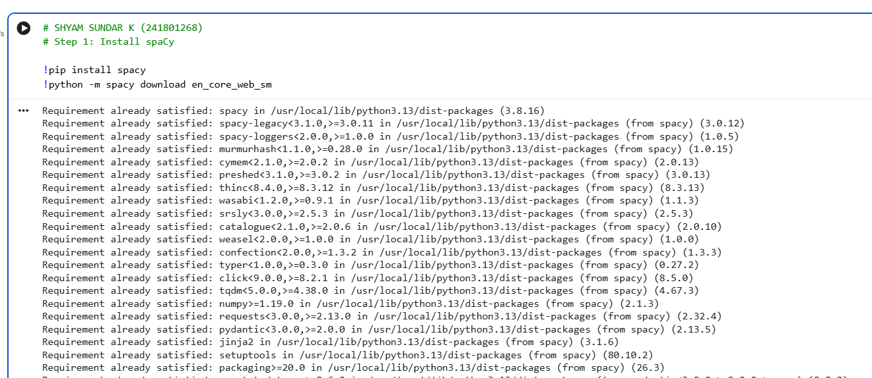

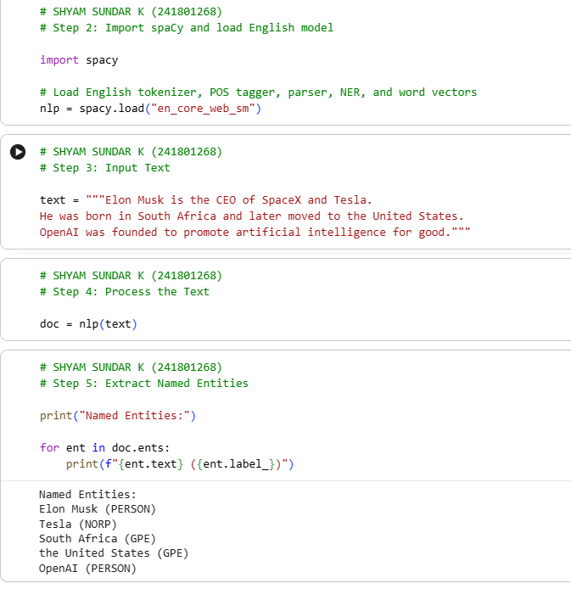
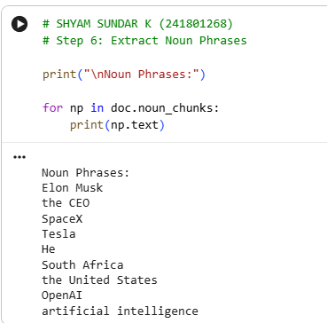
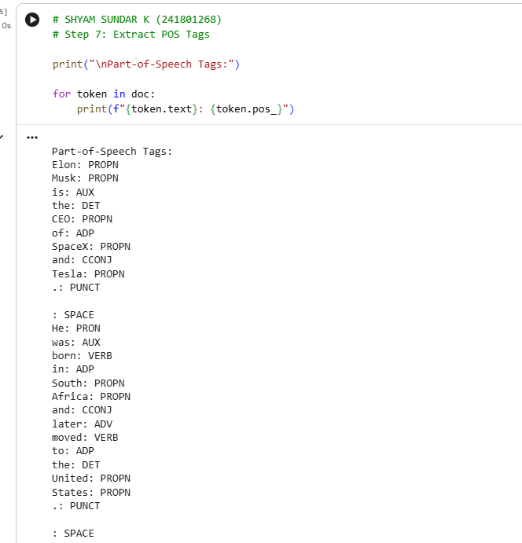

RESULT:
Thus, information extraction was successfully performed on the Amazon Fine Food Reviews dataset using spaCy. The customer reviews were processed to identify tokens, lemmas, and part-of-speech tags. Named Entity Recognition was used to extract entities such as persons, organizations, locations, dates, and quantities. The extracted information was organized into a structured DataFrame for further analysis of customer feedback.

